NETWORKING HOME LAB
PORTFOLIO
Hands-on configuration • Verification • Troubleshooting

Project 1 | MikroTik Routing and VLAN Lab
Project 2 | Ubuntu Server and WireGuard VPN
Project 3 | UniFi Wireless Network Integration
Project 4 | Cisco Packet Tracer Networking Labs

Prepared as a practical learning portfolio for entry-level Network Technician, IT Support, and Junior/Associate Network Engineer opportunities.
This document records practical lab work and the troubleshooting methods used. It distinguishes confirmed observations from incomplete work.

Project 1 — MikroTik Routing and VLAN Lab
Physical networking home lab | MikroTik CloudCoreRouter1036, CloudRouterSwitch326, hEX and hAP devices

1. Project Overview
This project documents hands-on practice with MikroTik routers and switches to learn LAN addressing, gateway configuration, NAT, VLAN concepts, port membership, and connectivity verification. The lab has been developed in stages, and the full multi-VLAN topology should be treated as a work in progress until every VLAN has been tested end-to-end.

2. Objectives
- Review device roles: core routing, distribution switching, and access connectivity.
- Configure and inspect IPv4 addressing, gateway settings, DHCP-related settings, and NAT.
- Practice VLAN interfaces, bridge VLAN tables, tagged and untagged ports, and VLAN filtering.
- Verify connectivity methodically and document faults, changes, and test results.

3. Network Topology
Internet/WAN → hAP ac lite upstream→ MikroTik core router (CCR1036, planned core role) → CRS326 distribution switch → Mikrotik Router hEX access devices → PCs, Intel NUC server, and UniFi APs.
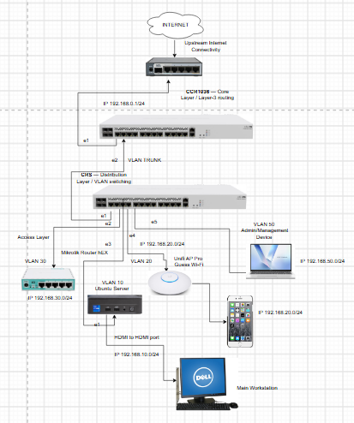

4. Configuration and Commands
The following are examples/reference commands. Adapt interface names, IPs, VLAN IDs, and device versions to the configuration you actually tested.

Useful inspection commands
/interface print detail
/ip address print detail
/ip route print detail
/ip dhcp-client print detail
/ip firewall nat print detail
/interface bridge print detail
/interface bridge vlan print detail

Example source NAT rule (adapt interface name)
/ip firewall nat add chain=srcnat out-interface=<WAN_INTERFACE> action=masquerade

Example VLAN interface (adapt parent interface and VLAN ID)
/interface vlan add name=vlan10 vlan-id=10 interface=<PARENT_INTERFACE>

5. Verification and Testing
- Confirm physical link state and interface names before changing configuration.
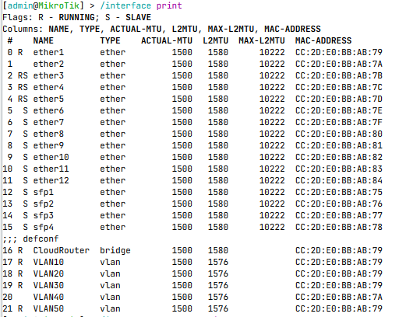
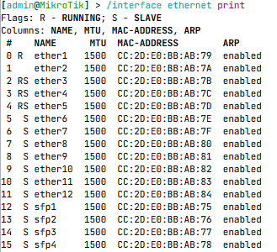
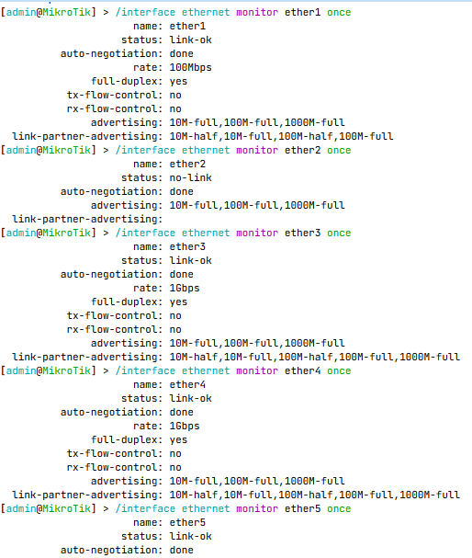

- Check IP addresses, default route, DHCP client/server state, and NAT rules.
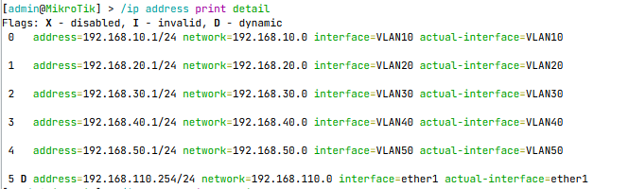
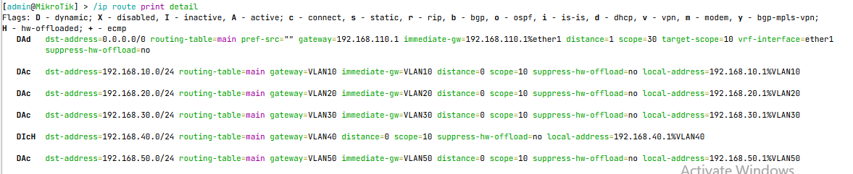
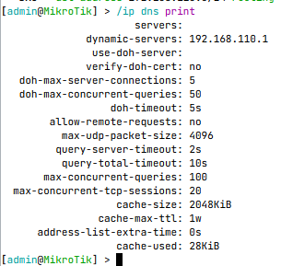
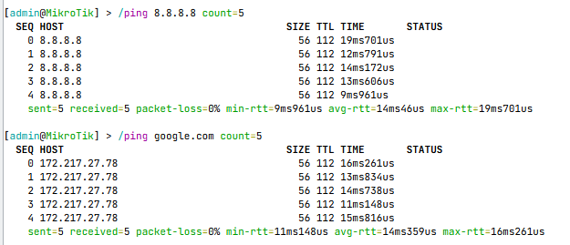
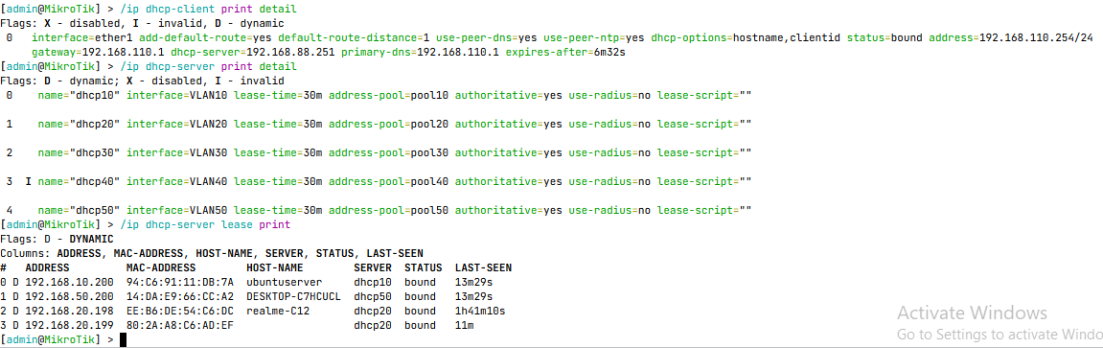
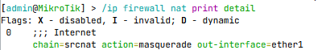

- Inspect Bridge → VLANs and confirm intended tagged/untagged membership.
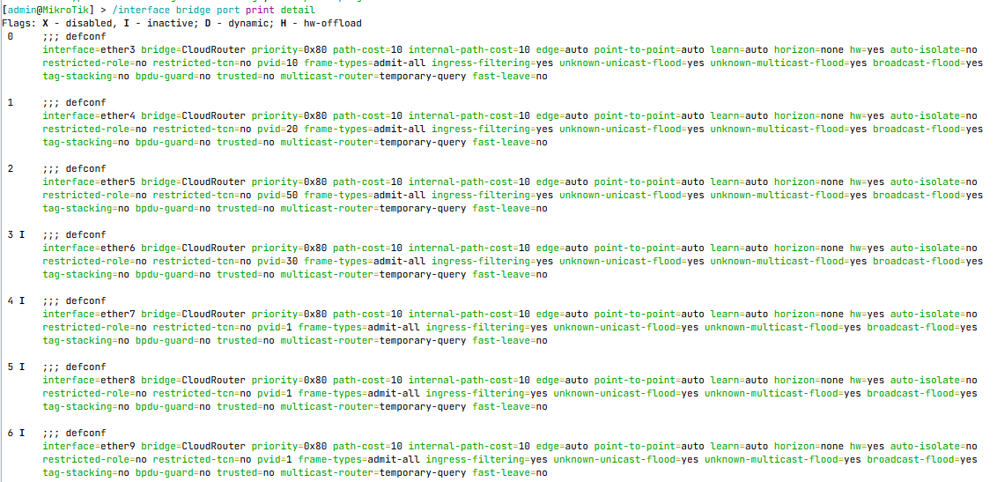
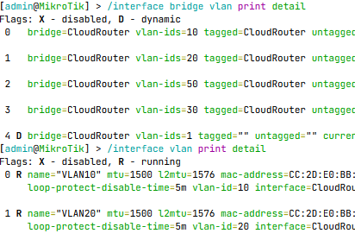
- Test same-VLAN connectivity first, then gateway reachability, inter-VLAN routing if configured, and Internet access.
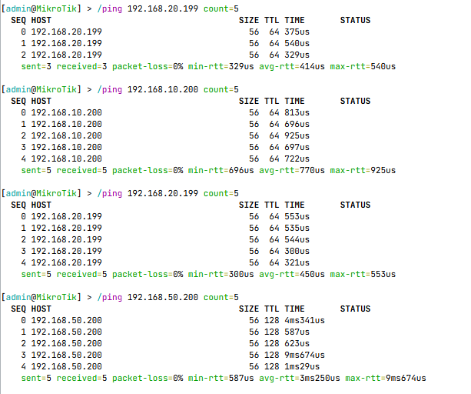
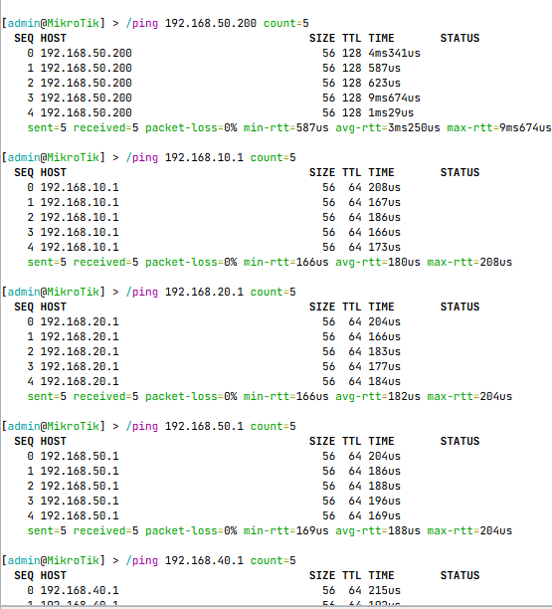
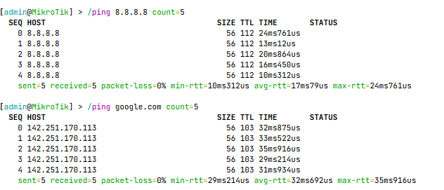
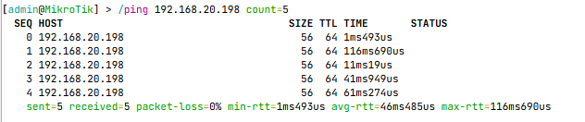

6. Troubleshooting Experience
- Internet access failed because of an incorrectly configured NAT rule; after correcting the rule, external IP and domain connectivity tests succeeded in that troubleshooting session.
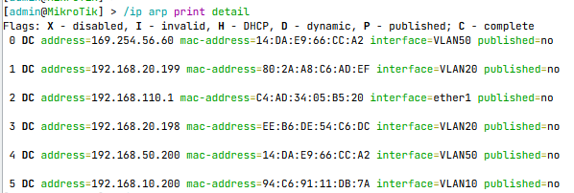
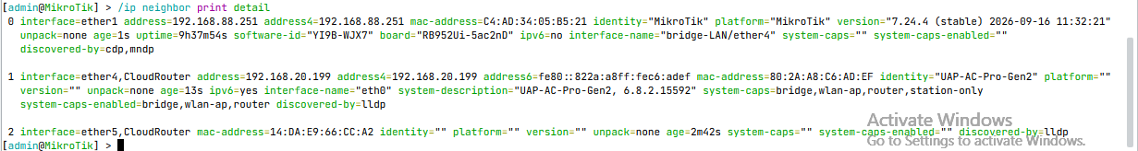
- Inspected bridge VLAN tables, port assignments, VLAN interfaces, and VLAN-filtering status while diagnosing VLAN connectivity.
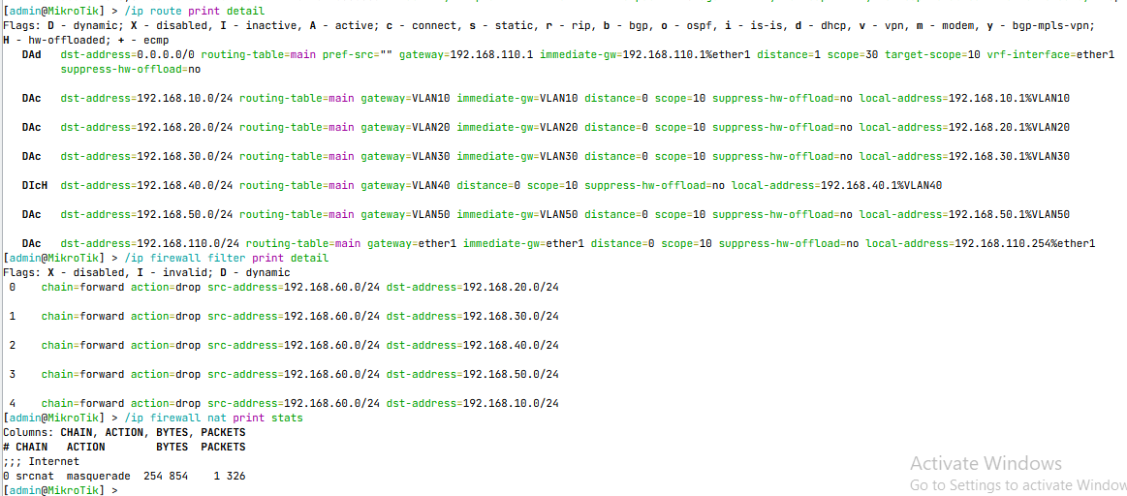
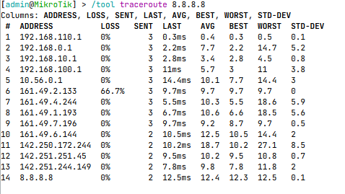
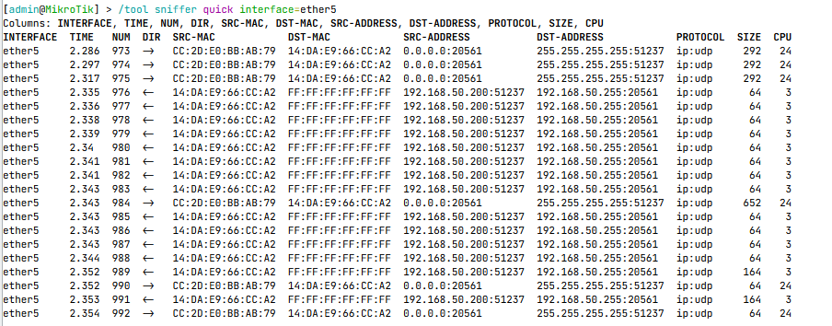
- Used ping, ARP/neighbor information, interface state, IP addressing, and route inspection to narrow down where connectivity failed.

7. Final Result / Current Status
Verified outcomes include correcting a NAT-rule issue and restoring Internet connectivity in that session. VLANs and the complete multi-device design remain configuration-dependent.

8. What I Learned
- How RouterOS interfaces, addresses, routes, NAT, and bridge VLAN tables relate.
- Why tagged/untagged port assignments and VLAN filtering must match the physical topology.
- Why changes should be made in small steps with a recovery path and before/after verification.

9. Real-World Application
These skills apply to small-office routing, departmental network segmentation, switch-port troubleshooting, and documenting a maintainable network.

10. Evidence Checklist
- Topology diagram with labels and IP/VLAN plan
- Configuration screenshot or sanitized command output
- Verification output showing successful tests
- Troubleshooting evidence: symptom → investigation → fix → retest
- Date, device/software version, and brief caption
For more information about my troubleshooting experience , you may see it to my files thank you!

